Software Requirements Specification

For

CSCTS PROJECT

Version 1.0 approved

Prepared by Sachin Chaurasia

ELogic Square Analytics Pvt Limited

30-Nov-2020

Table of Contents

Table of Contents ii

Revision History ii

1. Introduction 1

1.1 Purpose 1

1.2 Document Conventions 1

1.3 Intended Audience and Reading Suggestions 1

1.4 Product Scope 1

1.5 References 1

2. Overall Description 1

2.1 Product Perspective 2

2.2 Product Functions 2

2.3 User Classes and Characteristics 3

2.4 Operating Environment 6

2.5 Design and Implementation Constraints 6

2.6 User Documentation 6

2.7 Assumptions and Dependencies 6

3. External Interface Requirements 6

3.1 User Interfaces 6

3.2 Hardware Interfaces 6

3.3 Software Interfaces 7

3.4 Communications Interfaces 7

4. System Features 7

4.1 User Management 7

5. Other Nonfunctional Requirements 8

Appendix A: Glossary 9

Appendix B: Analysis Models 9

Appendix C: To Be Determined List 9

Revision History

|  |  |  |  |
| --- | --- | --- | --- |
| **Name** | **Date** | **Reason For Changes** | **Version** |
| Sachin Chaurasia | 30-Nov-2020 | Initial Draft | 0.1 |
| Sachin Chaurasia | 17-Dec-2020 | Workflows updated | 0.2 |

# Introduction

## Purpose

The purpose of the document is to define the details of the CSCTS (Coal Supply Chain Tracking System) to all the stack holders on the process of the coal movement, management in the plants

## Document Conventions

|  |  |
| --- | --- |
| CSCTS | Coal Supply Chain Management System |
| HHD | Handheld Device |
| UI | User Interface – Web Pages |
| Supplier | Coal Mines |
| Source | Source of the Coal |
| Transporter | Transporter of the Coal |
| Truck | Vehicle carrying the Coal |
| Hywa | Internal vehicles of the Plant |
| SR | Stacker Reclaimer |
| Dozer | Dozer |
| Rake | Railway Rake |

## Intended Audience and Reading Suggestions

The document is intended to all the stakeholders of the product like developers, project managers, delivery partners, testers and the plant teams and the IT team.

The document should be read in the above-defined format so that all the flow is observed as defined.

## Product Scope

The purpose of the CSCTS is to provide the details of the coal movement inside the plant, starting from the inbound to storage to consumption. It is also targeted at providing the movement of the truck through a nearly real-time view of the status of the trucks. The anomalies are detected and directed to the concerned stakeholders for further actions.

## References

# Overall Description

The User management system comprises of logically identifying the users of CSCTS. The user management system will able to register AD and non-AD users, profiles, roles and resources for each profile.

## Product Perspective

The CSCTS system stores the following information

* Plant Specific Roles Configurations
* Plant Specific Profile Configurations
* Plant Specific Profile to resource mapping

## Product Functions

### User Management

A user of the system shall be able to add, modify and deactivate users in the CSCTS application. The system shall support 2 privileges – add, edit. Users having the privilege are allowed to perform the required operations. The IT admin is given the functions to work on both. The appropriate privileges are available in the User Management document

* Add Users.
* Edit Users.
  + Modify the existing attributes of the Users.
  + Search the Users
  + Deactivate users.
* Add Profiles.
* Update Profiles
  + Modify the existing attributes of the profiles.
  + Search the profiles
  + Delete profiles (Soft delete)
    - Profiles can be deleted only when there are no users are mapped to it.
* Login / logout
* Password Reset.
  + Send email and SMS for new password

## User Classes and Characteristics

### User Management

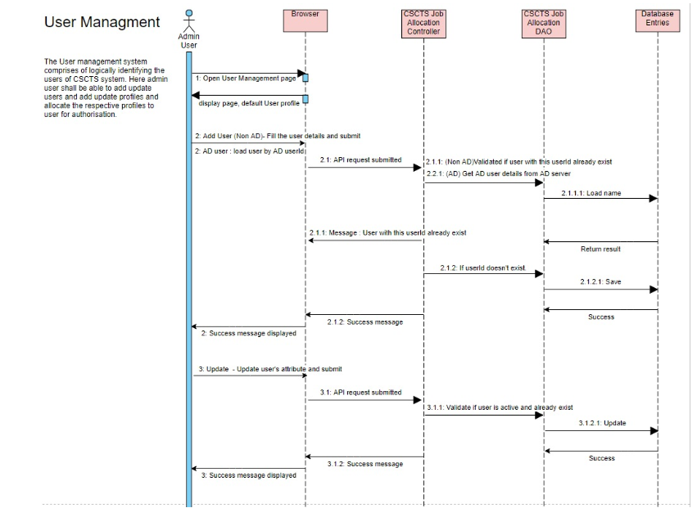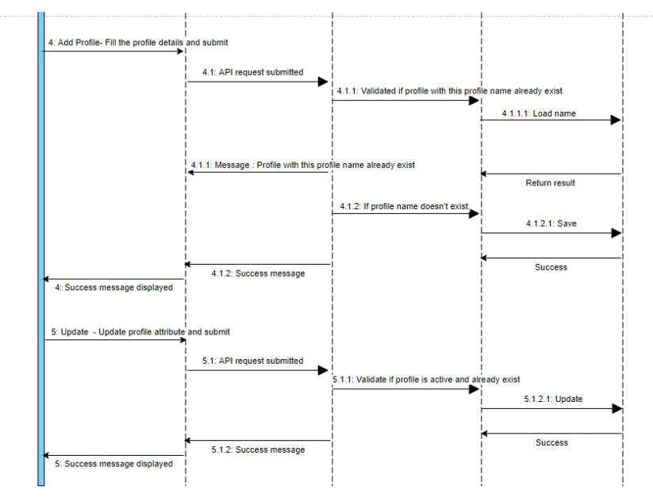

### Workflows

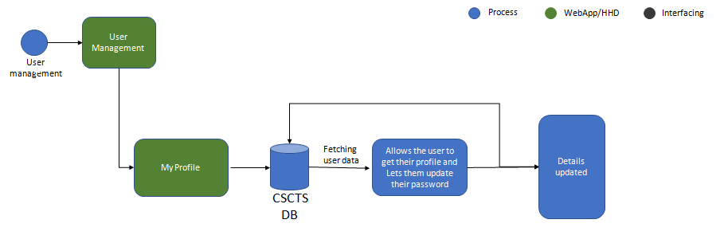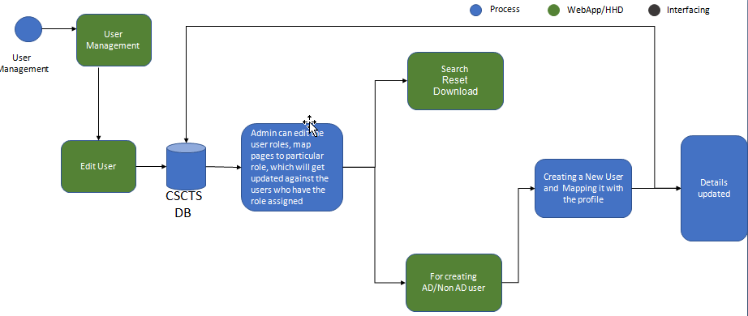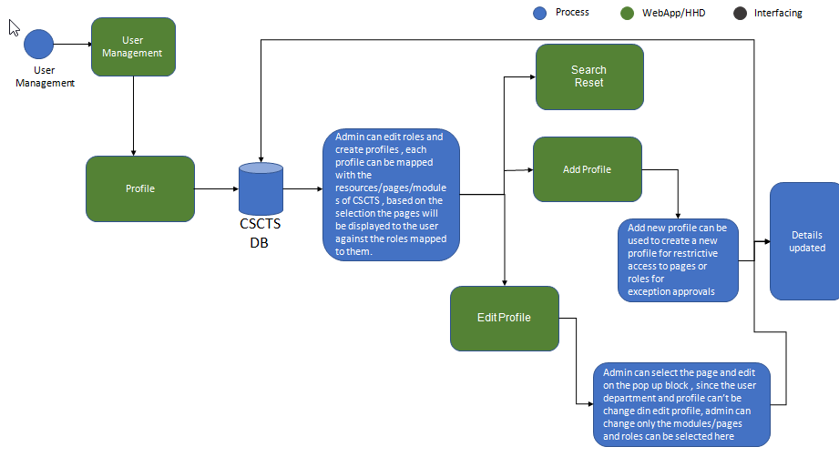

## Operating Environment

Operating environment for the CSCTS application is as below

* Oracle database
* Operating System: Centos Linux
* Client: Browser
* Platform: Java, Apache Ignite, Angular 8

## Design and Implementation Constraints

* Availability of roles and mapping of profiles with resources.

## User Documentation

Module wise user manual is provided during the feature releases.

## Assumptions and Dependencies

* The mapping of profile with resources and role mapping with be provided beforehand.

# External Interface Requirements

## User Interfaces

Front End Interface: Angular

Middle-End Interface: Java Rest API’s

Backend Interface: Oracle

Standards for User Interface:

## Hardware Interfaces

Linux – Centos 7.0

A browser which supports HTML and JavaScript

## Software Interfaces

Following are the software used for the CSCTS application

|  |  |  |
| --- | --- | --- |
| **Software Used** | **Version** | **Description** |
| Java | Java 1.8.0_u231 | To build the middle layer of the application, we have used Java |
| Apache Ignite | 2.7.5 | Ignite is used as an in-memory cache layer for the frequently used data |
| Oracle | 12.c | To save all the data related to the coal management |
| Angular | 8 | To create the user interfaces |
| Linux | Centos 7.0 |  |
| SMTP | In –house | Email Integration |
| SMS | SMS Gateway | SMS Integration |
|  |  |  |

## Communications Interfaces

* HHD devices are used by the operators within the plant on the ground, all through the track tracking process from gate entry to gate exit as required by the module.
* While all other users, use a web browser to access and manage the CSCTS processes
* Email and SMS are modes of notification/alert to the users as required by the module

# System Features

The Yard and Stock Pile Module are divided into 2 functional areas.

## User Management

### Description and Priority

The user Management shall provide the user and admin users with the ability to manipulate the data as per the requirement

### Stimulus/Response Sequences

* **Add Users.**
* **Edit Users.**
* **Add Profiles.**
* **Update Profiles**
* **Login / logout**
* **Password Reset.**

### Functional Requirements

* The user Management functionality shall provide a detailed view of the users and profiles.
* The module shall allow normal users to updated their password.
* The module shall allow admin users to add, update and deactivate users also add, update and soft delete profiles.
* The module shall allow admin users to modify the mapping of roles to profile and resources to profile and the same shall be effected to all the respective users.
* The module shall provide a login page to log in users where corporate users can also log in by selecting which plant they want to login.
* The module shall allow users to reset their password by sending an email and SMS to their registered email address and contact number.
* The module shall allow admin users to search users based on userId, profiles, roles and reports_to attributes on Edit user page.
* The Module shall able to register AD users as well by providing the AD userId.

## 

# Other Nonfunctional Requirements

* CSCTS modules or pages developed should be supported by Chrome and Edge
* CSCTS Web average page response should not be more than 5 secs
* Any or all CSCTS Web or HHD modules/functions should be accessed only by valid logged credentials
* Any or all operations performed should be audited/logged in CSCTS
* Any or all CSCTS Web pages will follow or adhere to these User Guidelines Principle

Appendix A: Glossary

<Define all the terms necessary to properly interpret the SRS, including acronyms and abbreviations. You may wish to build a separate glossary that spans multiple projects or the entire organization, and just include terms specific to a single project in each SRS.>

Appendix B: Analysis Models

<Optionally, include any pertinent analysis models, such as data flow diagrams, class diagrams, state-transition diagrams, or entity-relationship diagrams.>

Appendix C: To Be Determined List

<Collect a numbered list of the TBD (to be determined) references that remain in the SRS so they can be tracked to closure.>